1. Replace these branding images with the new versions in this zip (all same file names):

* favicon.ico
* temp-cloud-logo-blue.svg
* temp-cloud-logo-white.svg
* temp-pelco-breeze-wordmark.svg
* temp-pelco-wordmark-white.svg

1. Remove background stuff (lines 2-4) from login.less (or just replace modules/login.less with the new login.less file in this zip). Can also delete branding image temp-extra-clouds.svg.

Result should be that header looks like this:

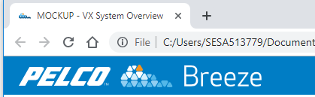

And login page looks like this:

